**South Dakota FFA Association** 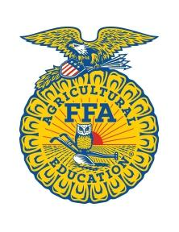

SDSU Wenona Hall 107 Brookings, SD 57007 (605) 688-4380

For Immediate Release

Photos available to download: <https://sdsu.box.com/s/9maorejepukcv1agd3rnfz6ez79shvpd>

**Esteemed Supporters Honored at Convention**

The South Dakota FFA Honorary State Degrees and Distinguished Service Awards were presented at the 94th Annual South Dakota State FFA Convention on April 25th, in Brookings, SD. These awards recognize outstanding contributions of time and talent to the South Dakota FFA.

The following companies and individuals received the Distinguished Service Awards:  
Pictured (left to right):

* Mark Ketelhut
* Lori Tonak
* Svennes Bussing- Lanny and Gayleen Svennes

Not pictured:

* Jim Wilson
* Cory Zirbel

The following individuals received Honorary State Degrees:

Back Row (left to right):

* Connie Whistler
* John Heylens
* Chris Nelson
* Jacob Englin
* Brady Jensen
* Rep. Caleb Finck
* Brad Reinke

Front row (left to right):

* Dawn Leber
* Michelle Nelson
* Erin Yost
* Dani Herring
* Sylvia Wolters
* Joshua Johnson

Not pictured:

* Dennis Clemens
* Ryan Beer
* David Koupal

**###**